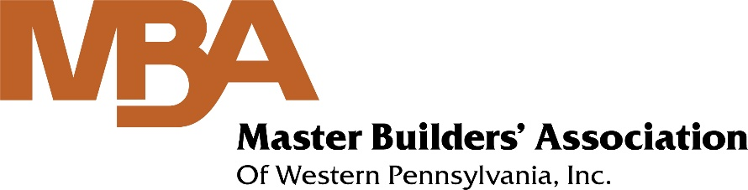

COVID-19 Symptom Screening Guide
In accordance with May 1 Construction Restart Guidance
This screening does not need to be documented unless the worker answers Yes
to any of questions 2-6 or has a temperature over the fever threshold (100.4° F).

- Do you have a fever?
- Do you have any COVID-19-positive members in your household?
- Do you have a cough?
- Do you have shortness of breath?
- Do you have fatigue or muscle aches?
- Do you have a new loss of taste or smell?
- Do you agree to report the onset of any of these symptoms during your shift?

Master Builders’ Association of Western PA, Inc. • 412.922.3912 • www.mbawpa.org

