CONTACT  Master Builders’ Association  412.922.3912  estarkowicz@mbawpa.org  www.mbawpa.org | FOR IMMEDIATE RELEASE

The 2020 MBA Safety Champion Award

Presented by MSA – The Safety Company

Presented to Chris DiBon, General Superintendent,

Mascaro Construction Company, LP

February 25, 2021

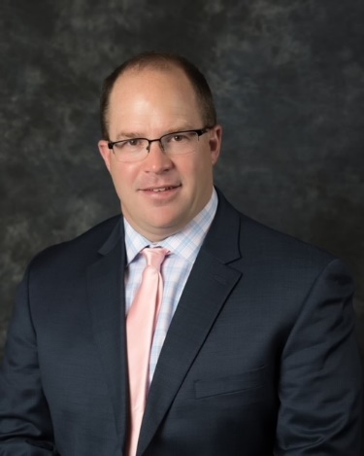
Pittsburgh, PA – The Master Builders’ Association of Western Pennsylvania, Inc. (MBA) is pleased to announce the 2020 Safety Champion Award winner, Chris DiBon, General Superintendent, Mascaro Construction Company, LP. The award was presented by MSA – The Safety Company at the fourteenth annual Construction Industry Evening of Excellence on Thursday, February 25, 2021. This year’s event was held virtually, thanks in part to our Virtual Media Sponsor, Mechanical Contractors Association of Western Pennsylvania.

The MBA Risk Management Committee established the Safety Champion Award to recognize one individual, who is known within their company and the construction industry as a person who consistently practices the safety leadership skills needed to create a strong jobsite and organizational safety climate.

MBA members submit individuals within their company who they feel exemplify the very best qualities of safety leadership. An independent panel of judges consisting of locally and nationally recognized safety professionals evaluate each application. The winner is then selected based upon six safety leadership criteria including: their commitment to safety, display of caring and respect for their fellow worker, and what they have done to go above and beyond traditional safety efforts to ensure that their co-workers go home healthy and safe each day.

This year’s nominees were particularly impressive to the judging panel. However, as impressive as the submission were, Chris stood out to the judges. It was apparent that he leads by example in his role as General Superintendent at the UPMC Vision and Rehabilitation Hospital at Mercy. In particular, the judges were impressed with how Chris takes an interest in employees physical, as well as mental well-being. He provides a welcoming project environment for all tradespeople.

About the MBA
Purpose
Leading the Industry, Building the Region!

Vision
To support and advocate for our members and community by promoting:
- Safety
- Diversity and Inclusion
- Labor Relations
- Workforce Development

Since 1886, MBA contractors have set the standard in Western PA for construction excellence by investing in a skilled workforce, implementing award-winning safety programs, and offering the best in management expertise.

For more information on the MBA, please call 412.922.3912 or visit www.mbawpa.org

## end ##

