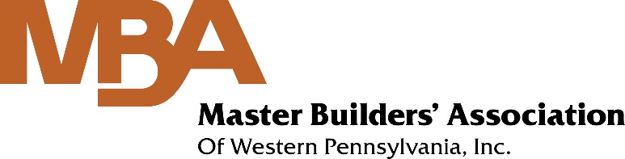
CONTACT  Master Builders’ Association  412.922.3912  estarkowicz@mbawpa.org  www.mbawpa.org | FOR IMMEDIATE RELEASE

The 2020 James Kling Fellowship Award

Presented by the AIA-MBA Joint Committee to Steven Bishop

February 25, 2021
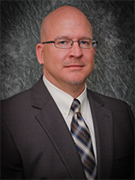
Pittsburgh, PA – AIA-MBA Joint Committee rewards collaboration between area Architects and General Contractors

Steven Bishop was named the 2020 James Kling Fellowship Awardee by the AIA-MBA Joint Committee. Steve’s career was celebrated as he was honored at The Construction Industry Evening of Excellence on Thursday, February 25, 2021, during the virtual awards ceremony. AIA-MBA Joint Committee Co-Chairs, Shawn Bell (Turner Construction) and David Wells (RM Creative) presented the award to Bishop, who also accepted remotely.

The James Kling Fellowship Award was established by the AIA-MBA Joint Committee to recognize those individuals who best exemplify collaboration between the design and constructor professions. These individuals, through their action and example, provide both members of the AIA and the MBA standards of excellence to strive for in an effort to bridge the gap between both professions.

For more information on this award, including past winners, visit: James Kling Fellowship Award

About the AIA-MBA Joint Committee: Chartered in 1965, the AIA-MBA Joint Committee consists of Architects, General Contractors, Legal Counsel and Owners, who collectively represent the best interests of the American Institute of Architects Pittsburgh Chapter, the Master Builders’ Association of Western PA and the region’s entire design and construction community. The AIA-MBA Joint Committee provides a unique forum that promotes the exchange of ideas between industry stakeholders. These activities have advanced the cooperative working relationship enjoyed by both associations and the commercial construction industry at large.

For more information on the AIA-MBA Joint Committee, please call 412.922.3912 or visit their website.

## end ##

